Quadratic sequence
A quadratic sequence is a sequence of numbers in which the second difference between any two consecutive terms is constant.
Consider the following example: 1; 2; 4; 7; 11;…

The first difference is calculated by finding the difference between consecutive terms:
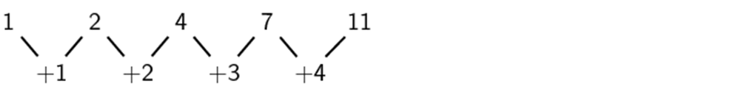
First difference
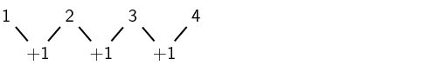
The second difference is obtained by taking the difference between consecutive first differences:
Second difference

We notice that the second differences are all equal to 1. Any sequence that has a common second difference is a quadratic sequence.
NB: It is important to note that the first differences of a quadratic sequence form a sequence. This sequence has a constant difference between consecutive terms. In other words, a linear sequence results from taking the first differences of a quadratic sequence.
Exercise 1
Determine the second difference between the terms for the following sequences:
- 5 ; 20 ; 45 ; 80 ;…
- 0 ; -6 ; -16 ; -30;…

